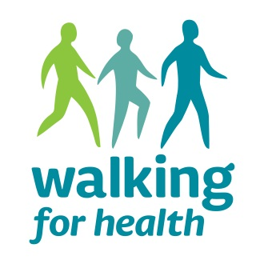
Volunteer Walk Leader Training Booking Form

Tuesday 14th January 2019 10:00 am – 2:00 pm
Venue TBC

Your details
Name…………………………………………………………………………………………………………………
Address…………………………………………………………………………………………………………………………………………………………………………………………………………………………………………..Postcode………………………………………………..
Tel…………………………………………………………
Mobile…………………………………………………..
Email……………………………………………………………………………………………………………………

Why are you applying to be trained as a health walk leader?

....……...................................................………………………………………………………………………………………

…………………………………………………………………………………………………………………………………………………….

Which walk or walks do you currently attend?

...........................................................................................................................................

…………………………………………………………………………………………………………………………………………………….

Which walk or walks are you interested in leading or back marking for?

......................................................................................................................................................

.......................................................…………………………………………………………………………………………

How often would you like to lead or back mark? (please select one answer)
- Several times per week
- Once per week
- Once or twice a month
- A few times a year
- Not sure

PTO

Do you have any other experience, skills or interests you would like to mention?
e.g. First aid, member of a local history group, wildlife trust

….…………………………………………………………………………………………………………………………........................

..........................................................................................................................................

Do you have any special requirements when attending a training course? Please give details

…………………………………………………………………………………………………………………………………………………….

.……………………………………………………………………………………………………………………………………………………

Refreshments are provided. Please bring with you your own lunch for the day.

PTO
Using and sharing your information
Your information will be held by Winchester City Council in order to update you on the training and issue your certificate. Under the General Data Protection Regulation (GDPR) your information will not be shared with any other parties.

Are you happy for Winchester City Council to keep your details for the training administration purposes only Yes / No*

Signed:…………………………………………………………………………………………………………..Date:………………………………..

Please return this form:

by post
Chloe Davanna
Sport and Physical Activity Officer
Winchester City Council
Colebrook Street
Winchester
SO23 9LJ

by email
cdavanna@winchester.gov.uk

or to talk to someone about the training call:
01962 848 493

